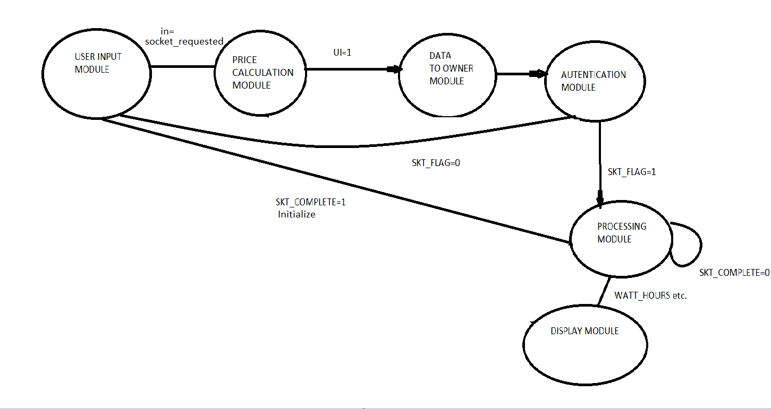

void loop() {

int in=input_socket();//also checks if the socket is free

int UI=price_calc(in); //price calculation for socket

if(UI==1){

//send data to owner

Serial.printf("\ndata sent for authentication (socket %d)\n",in);

delay(1000);

//authentication from owner for socket x ,do: SKT_FLAG [x]=1

SKT_FLAG[1]=1;

SKT_FLAG[0]=1;

if(SKT_FLAG[in]==1)

{

Serial.printf("permission granted for socket %d\n",in);

StartTime[in]= millis();

turn_on_relay(in);

}

else{

Serial.printf("permission denied for socket %d\n",in);

}

}

delay(1000);

for(int i=0;i<n;i++){

if(SKT_FLAG[i]==1){

processing_mod(i);

}

}

}

